Day-4 Prolog Programs
- Create a Prolog program that generates exam questions related to students, teachers, subjects, and codes. In this program, you have to create a knowledge base with some facts, and then generate questions based on that knowledge. The questions will be in the format of "fill in the blank".

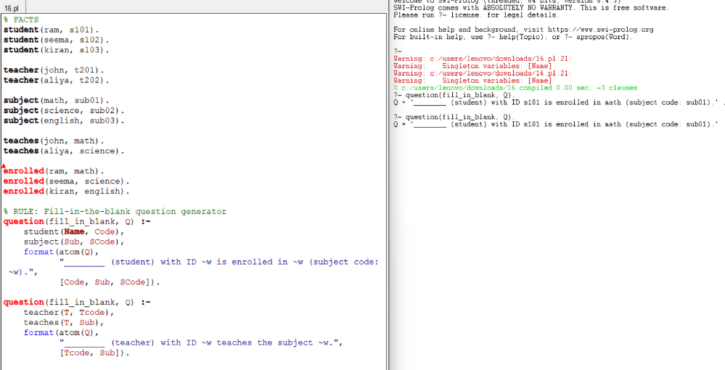

- In forward chaining, you start with initial facts and rules and iteratively apply the rules to derive new facts until a goal is reached. Define a simple scenario with a few rules and facts. Using prolog, you have to determine whether someone is a parent based on their gender and whether they have a child.

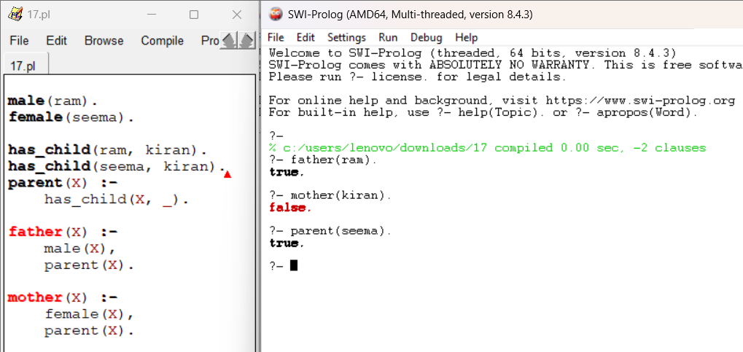

- Write Prolog facts to represent the following information about specific planets in the PLANETS database:
  - Planet Mercury's distance from the Sun and mass in Earth masses
  - Planet Saturn's orbital period and day length in Earth days and hours, respectively
  - Write a Prolog rule to find the distance between two planets based on their positions from the Sun.
Provide an example query to find the distance between Planet Venus and Planet Jupiter
  - Create a Prolog query to find all planets that are closer to the Sun than Planet Earth. List the planets that match these criteria.

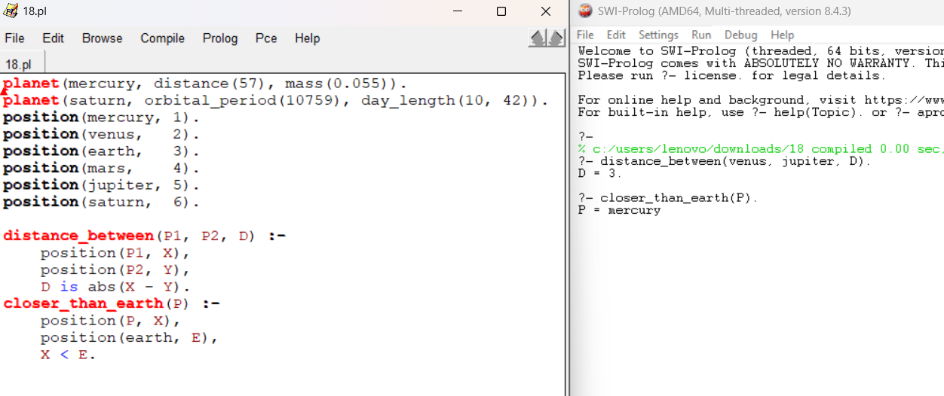
- In this program, define symptoms and conditions, create rules for diagnosis, and provide an interactive interface for patients to input their symptoms. The program then tries to diagnose the patient based on the symptoms provided. Use prolog program to implement the above scenario.
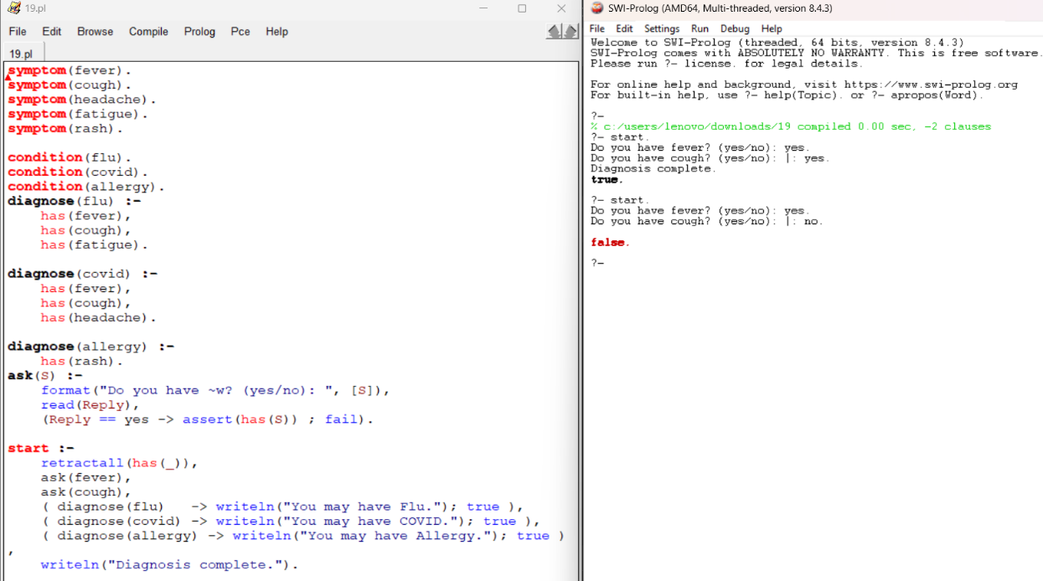
- You are tasked with implementing a family tree in Prolog. Use the following information to create a family tree database:
  - John is the father of Lisa.
  - Mary is the mother of Lisa and Mike.
  - Lisa is the sister of Mike.
  - Tom is the father of Mary.
  - Mike is the father of Emma.
  - Emma is the mother of Olivia.
  - Tom is the grandfather of Olivia.
Write Prolog predicates and rules to represent this family tree and answer the following queries:
- Who is the father of Emma?
- Who is the sister of Mike?
- Who is the grandmother of Olivia?
- Is John the grandfather of Olivia?.

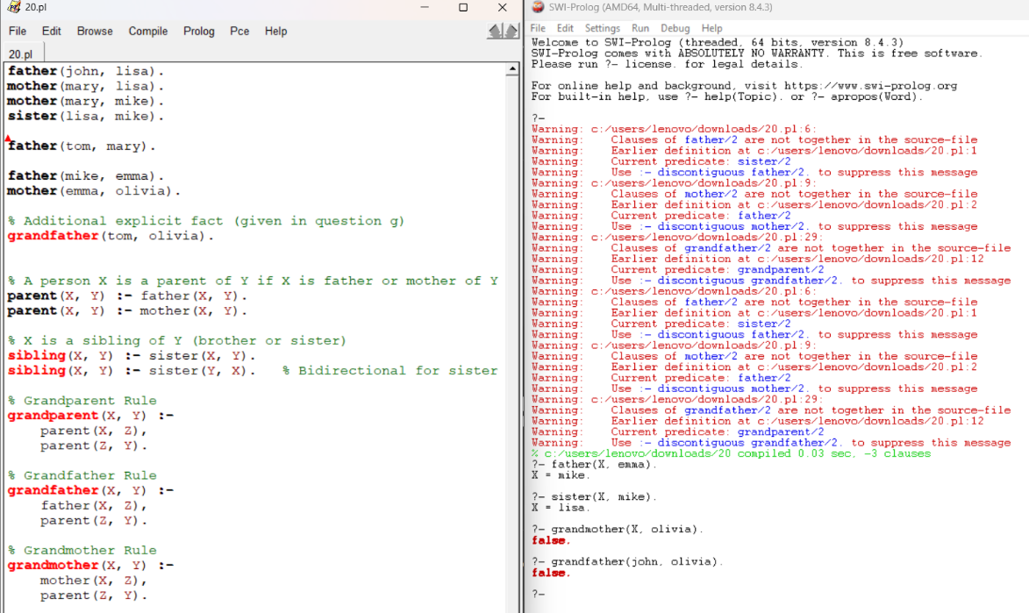

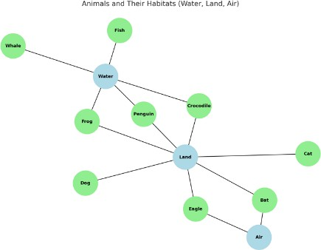
- Write a Prolog program to represent animals and their habitats. Include rules to determine which animals live in water, on land, and can fly.

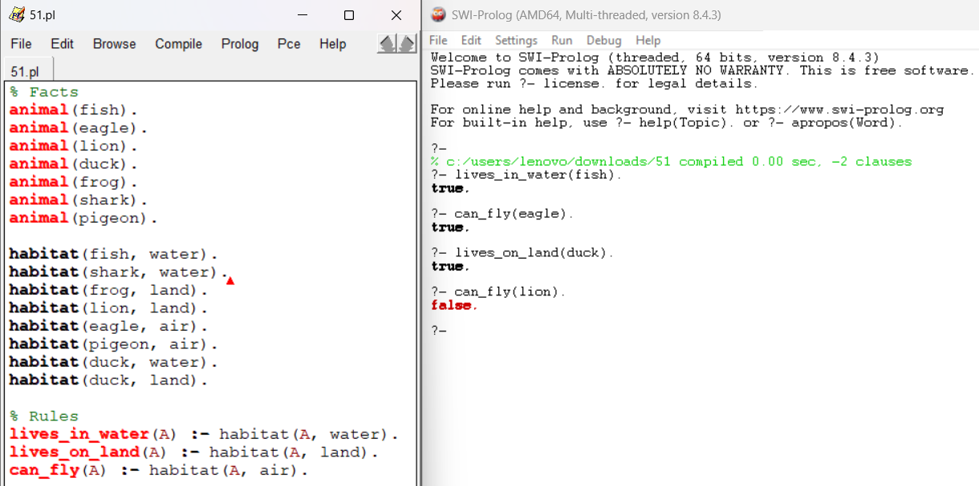

- Create a Prolog program for medical diagnosis of fever. Include symptoms such as cough, cold, headache, malaria, typhoid, and flu.

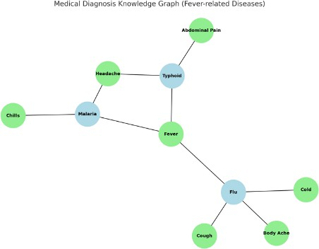

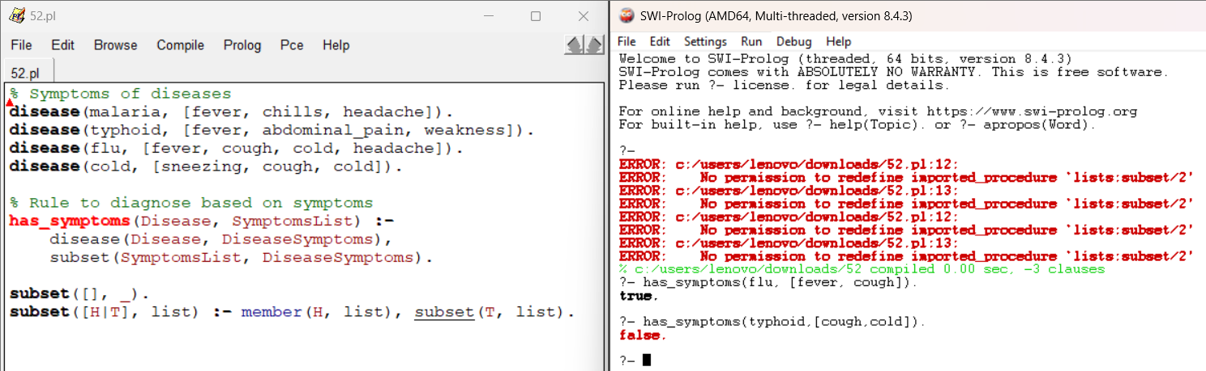

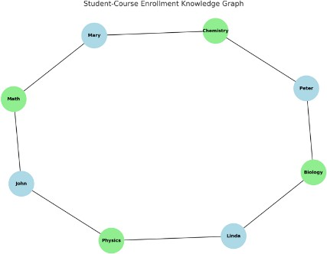
- Develop a Prolog knowledge base for a student-course enrollment system. The program should answer queries such as “Which courses does a student take?” and “Which students are enrolled in a course?”.

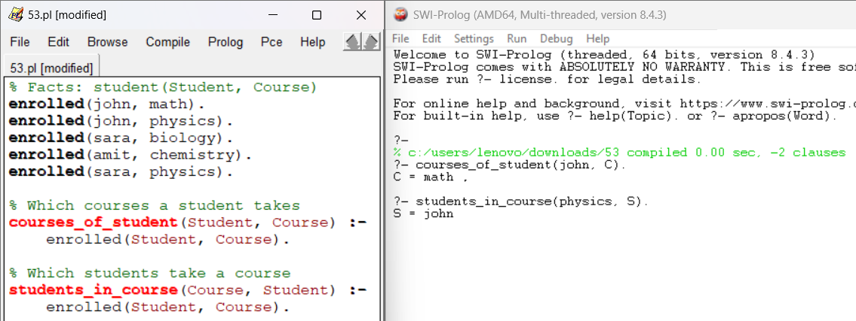
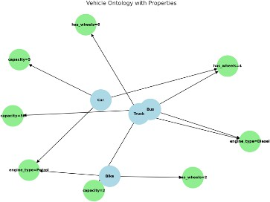
- Write a Prolog program to represent a small ontology of vehicles (car, truck, bike, bus) with their properties. Include reasoning rules to classify vehicles based on attributes.

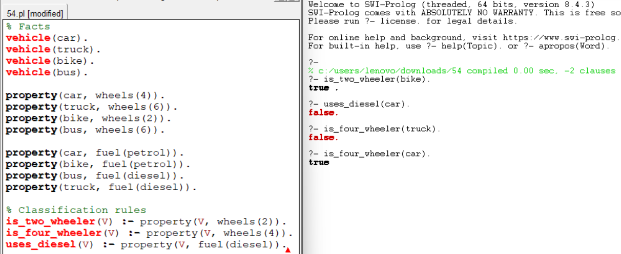

- Develop a Prolog program for restaurant menu recommendations. Define facts about dishes (veg/non- veg, spicy/mild) and rules for recommending dishes to customers.

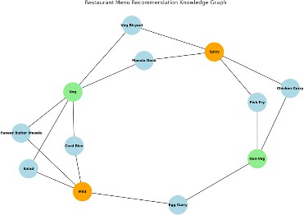

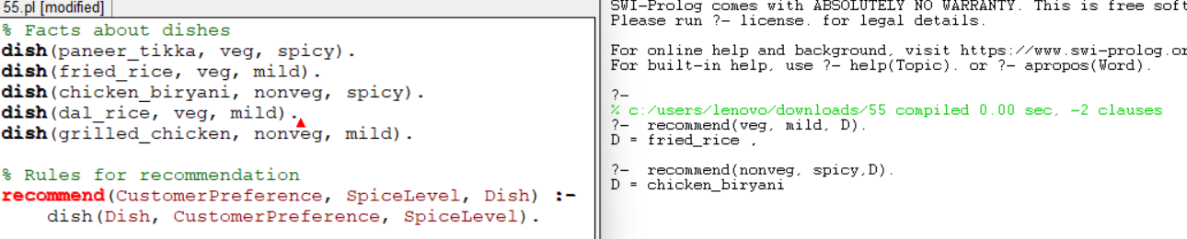
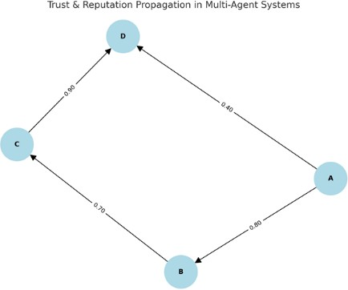
- Write a Prolog program to simulate trust and reputation in multi-agent systems. Include rules or reputation propagation.
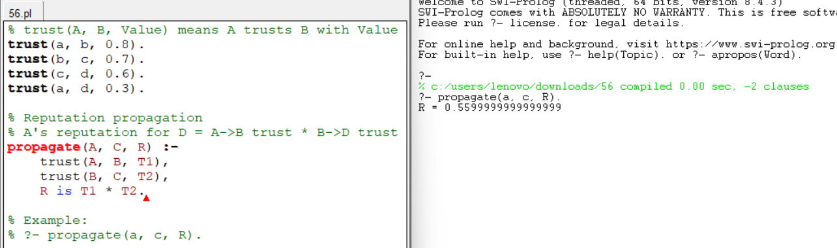

- Write a Prolog program to demonstrate backward chaining for a simple legal reasoning system (e.g., whether a person is eligible to vote).

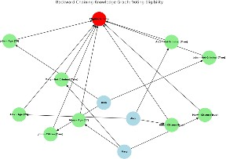

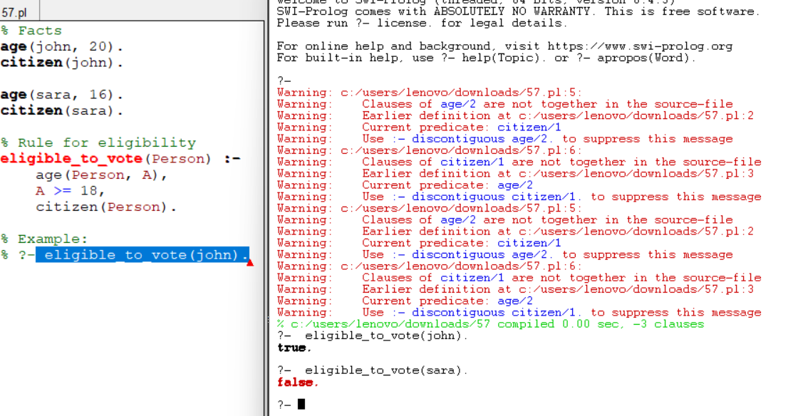

- Write a Prolog program for semantic network representation of relationships among concepts such as
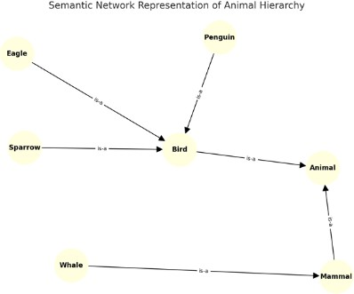
“bird → animal,” “sparrow → bird,” and queries to infer hierarchy.

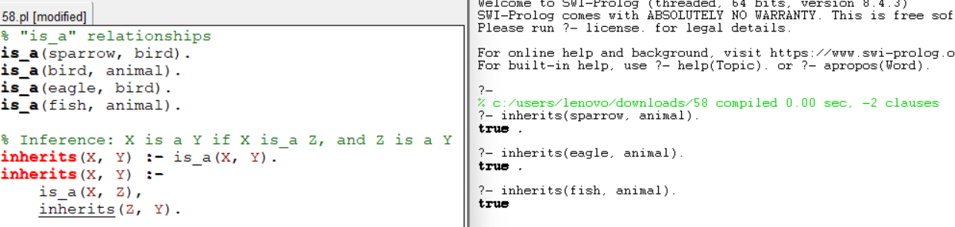

- Write a Prolog program that models an argumentation framework among agents and checks whether a given argument is accepted or rejected.
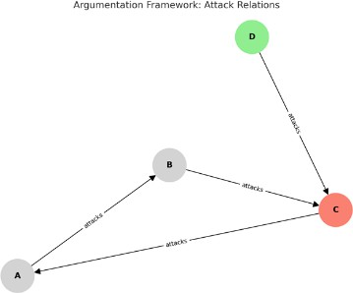

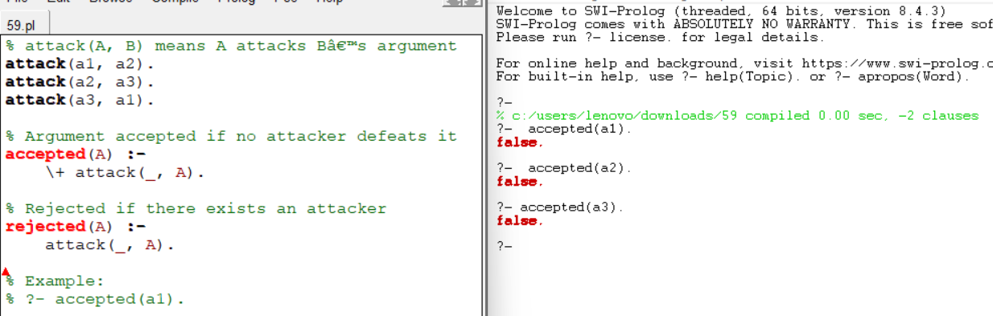
- Write a Prolog program that represents knowledge using frames. Create frames for “Car,” “Electric Car,” and “Hybrid Car,” and show inheritance of attributes.
